OFFICE HOURS: We’re open Monday thru Thursday 8:00 am to 4:30 pm. On Friday we’re open 8:00 am to 3:00 pm. You can reach us by phone at 503.829.6183; fax to 503.656.0320; visit our office at 820 7th Street, Oregon City; or you can e-mail us from our website at www.molallasanitaryservice.com. Our office staff will be happy to help you with any questions, problems, or concerns.  HOLIDAYS: The OFFICE is closed on New Year’s Day, Memorial Day, the 4th of July, Labor Day, Thanksgiving, and Christmas. Your garbage will be picked up on all of these holidays except Christmas & New Year’s Day. When Christmas & New Years fall on a week day, we shift the pick up schedule one day and wrap up the pick up week on Saturday. If your regular pick up day falls on or after these 2 holidays, you’ll be picked up one day later than usual both those weeks. [For example, if Christmas and your normal pick up both fall on a Thursday, you’d be picked up on Friday and the normal Friday customers would be picked up on Saturday.]  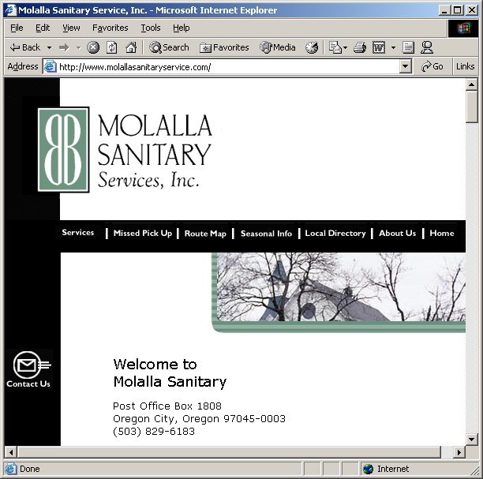  Visit us on the web at www.molallasanitaryservice.com  CHANGE IN SERVICE: Any request for a change in service – for example, if you need a different size container, you’re going to move, or you need the name on your account changed – must be made by phone, e-mail, or in writing. The request must be made directly to our office. We will continue to bill your account normal charges until we receive your request. |  | BILLING TERMS: Most residential customers are billed bi-monthly, the invoice covers the current month and one month in advance, plus any extra or special pick ups since the last bill cycle. Residential customers may request monthly billing at any time and will be automatically assigned monthly billing if delinquent notices are mailed. Commercial customers are billed monthly in arrears, but will be changed to billing in advance if late notices are mailed.  If you’ve questions about your bill, please contact us immediately.  Invoices for all regular garbage services are due on the 15th. Molalla Sanitary Service reserves the right to accrue a 1.5% monthly finance charges on any past due balance and there is a $20.00 charge for any returned check or payment. If you accept our service, you must agree to these terms.  Delinquent accounts can be terminated. You’ll be notified that your account is past due via mail – either on your monthly bill or with a statement. If you don’t pay or make arrangements to pay, our equipment can be pulled and all services stopped. If your services are stopped due to failure to pay, and you want to restart, you will have to: [1] Pay your account balance in full; [2] Pay a 2-month deposit; [3] Pay a $5.00 reinstatement fee; and [4] Ask to be restarted. We will not restart a service without you explicitly asking us to do so. If you leave a voice message to restart, please remember to give us your account number and full name.  PAYMENTS: Checks can be mailed. Or they can be dropped off at our office. We can also take VISA, MasterCard, Discover, or American Express credit card payments over the phone.  VACATIONS: If you’re going to be gone for 3 or more weeks, call the office before you go. Your account will be credited for the time you are away. Please note: You must call in advance or no credit will be applied.  For those going on vacation for only 1 or 2 weeks, please note that we only charge for 48 weeks out of the year. These 4 free pick ups are intended to cover those times when you’ve not set your garbage out for one reason or another – whether you just forgot it or were on a short vacation. Please don’t call asking for credit unless you’ll be gone for more than 3 weeks. |  | GARBAGE CANS & CARTS: Wherever possible, we run automated routes – meaning our drivers can pick up and empty your container without leaving the truck. A typical automated route can pick up twice as many houses in one day as a traditional garbage truck can – this goes a long way toward helping us keep our costs down. However, it also means you have to use one of our roll carts approved for use with an automated truck. We can provide 20, 35, 60, or 90-gallon roll carts for curbside use on all routes. Your rate will depend on the size of cart you select. You are responsible for the roll cart and must keep it clean. If it’s damaged or broken, please call the office for a repair. We also provide 2 recycle bins, and for our yard debris customers, a 60-gallon yard debris cart.  If you’re on a route that doesn’t use an automated truck, and you’re still using your own can, please remember it can be no larger than 32-gallons. [Molalla Sanitary Service will not be responsible for normal wear and tear on customer-owned cans.] And keep in mind your can cannot weigh more than 65 pounds for any one pick up. For safety reasons, our drivers have been instructed to skip any over weight cans or anything larger than 32-gallons. We cannot service barrels, well cans, or underground storage containers. You can, of course, contact our office for a roll cart, even if you’re not on an automated route.  In addition to our roll carts, commercial customers have a wide variety of large containers to chose from. Call our office for assistance in selecting the size that’s right for you.  GARBAGE OUT BY 5:00 AM: Your garbage, recycling, and yard debris [if you are a yard debris customer] must be at the curb by 5:00 am on your pick up day. If it’s not out, and we have to go back for it, you’ll be charged a $7.00 per truck return fee.  POSITIONING ROLL CARTS: Please make sure our truck can get to your cart! Make sure the wheels of the roll cart FACE the street. Put the cart within 3 feet of the curb – and remember clearance! Your cart cannot be blocked by trees, cars, bicycles, etc., or our truck cannot get to it. Don’t put your cart next to a parked car, under tree limbs, or in drainage ditches. And please! Do not tie the lid down! If you have any questions about where to put the cart, ask our driver when he makes your pick up. |  | UNACCEPTABLE MATERIALS IN GARBAGE CANS or CARTS: Please don’t put the following items in your garbage can or cart: Dirt, rocks, concrete, plaster, bricks, hot ashes, large chucks of Styrofoam, liquids, an excessive amount of fruit, any medical sharps, or any hazardous waste. Call 503.655.0480 if you have any questions as to what hazardous waste may be and how best to dispose of it. And please! DO NOT pack roll carts! If carts are packed tight, they cannot be readily emptied and left over garbage will remain in the cart. You will have to loosen this garbage yourself before our truck comes back next week. Molalla Sanitary Service will not be responsible for packed garbage remaining in your cart.  All shredded paper and Styrofoam peanuts must put in a garbage bag before going into your cart/can, as these materials can cause environmental problems if they are loose. Close and securely tie any plastic bags before you them put in.  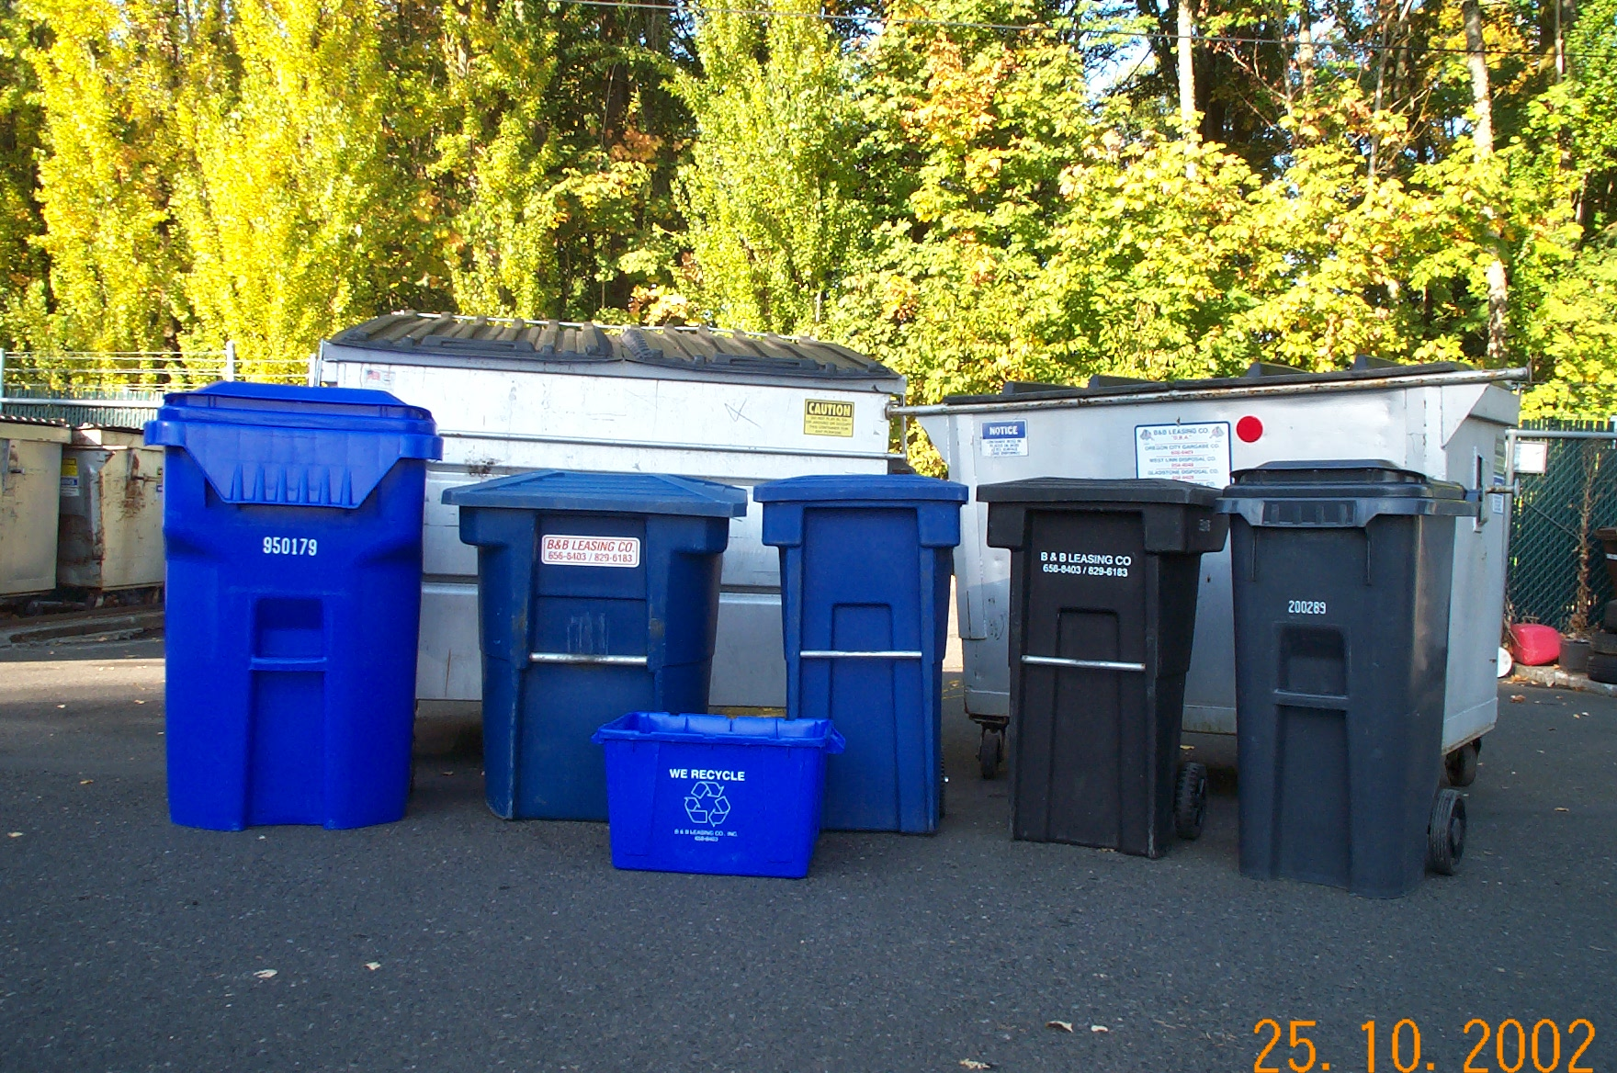  Roll Carts come in 20- 35- 60- or 90-Gallons  Please make sure the lid on your cart/can is completely closed. Trash can escape from any can or cart that is filled too full, and on our automated routes, if a roll cart is so full the lid doesn’t completely close, trash can be scattered when the truck lifts it – and the driver is not able to see it. Molalla Sanitary Service will not be responsible for trash that may be scattered when your cart or can is over-loaded. Further, if the can or cart is full beyond capacity, you’ll be charged for an extra pick up.  And please, DO NOT pile extras on top of the lid. Set your extras off to the side, leaving enough room for the driver to pick up your cart or can.
MISSED PICK UPS: If we miss your pick up, and your cart was out on time, it’s your responsibility to call the office as soon as possible. If you call early enough – usually before noon – we’ll send another truck around the same day. If it’s too late, we’ll send a truck to make your pick up on the next day. Molalla Sanitary Service will not credit your account for a missed pick up. If neither later in the day nor next day service will work for you, we’ll ask you to set out the missed pick up as a no-charge extra on your next regular pick up day.  If we didn’t make a pick up because your container was either not out on time or was not placed properly at the curbside, and we send another truck either the same day or the next day, your account will be charged a $7.00 per truck return fee.  EXTRA PICK UPS: Normally, if you’re going to have an extra bag or box for us to pick up, you don’t need to call the office ahead of time. Our driver will pick up the extra garbage and you’ll see the charge on your next invoice. Extra trash must be tightly bundled, bagged, or boxed, and any one extra must not weigh more than 40 pounds. Set your extras off to the side, leaving enough room for the driver to pick up your cart or can.  However, it’s always a good idea to call the office and let us know if you’re going to have extras. It can be hard for a driver to know whose house an extra belongs to. You can save yourself – and us! – a hassle if you call ahead. In some cases, we’ll flag an account as “no extras without authorization” – meaning we’ve told the driver not to take any extra unless you have called in advance for it.  SPECIAL PICK UPS. If you have a special pick up – such as a big piece of furniture or an appliance – you must call the office and let us know in advance – this lets us send the appropriate crew to make the pick up . While you’re on the phone, we’ll tell you how much it’ll cost as prices vary based on the item(s) being picked up. |  | RECYCLING MATERIALS: You’ve been provided with 2 recycling bins; please use one for paper and the other for glass/tin/plastic, etc. Newspapers, magazines, catalogs, phone books, and paper bags can be put in the paper bin loose. Use a paper grocery bag for small paper items, such as junk mail, scrap paper, milk cartons, or juice boxes. Just put the bag in your paper bin. Cardboard needs to be flattened and anchored [so it won’t blow around].  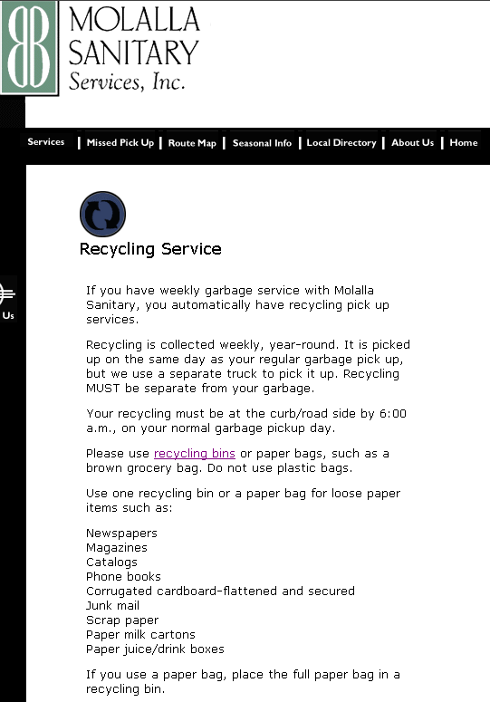  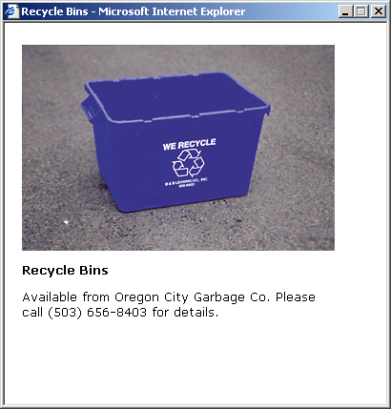  Use the other bin for plastic bottles, milk jugs, aluminum or tin cans, aerosol cans, and scrap metal. Use a paper grocery bag for all your glass jars and put it in this bin, too. Never use plastic bags for recycling – as these cannot be recycled. We can take motor oil. It must be in a see-through, 1-gallon plastic jug with a tight screw on lid – and please! – no more than 2 jugs per week. |  | SNOW & ICE: Occasionally, bad weather makes us miss a day. Should our drivers be grounded due to snow or ice, we’ll shift the pick up schedule one day, and wrap up the pick up week on Saturday.  For example, if your normal garbage pick up day is Wednesday, and we couldn’t get our trucks out, you’d be picked up on Thursday; the normal Thursday customers would be picked up on Friday; and the Friday customers would be picked up on Saturday.  Sometimes we’ll decide to run the garbage trucks, but will ground both our yard debris and recycling trucks. If the weather looks bad, please hold your recyclables and/or yard debris until the following week.  B&B Leasing, Inc.  dba  Molalla Sanitary Service  P. O. Box 1808  Oregon City, OR 97045  503.829.6183  fax 503.656-0320  www.molallasanitaryservice.com |  | Molalla Sanitary Service  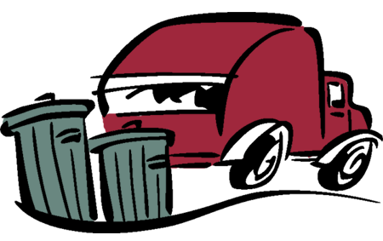  Customer Information Brochure  Molalla Sanitary Service Company  P. O. Box 1808  Oregon City, OR 97045  503.829.6183  fax 503.656-0320  www.molallasanitaryservice.com

